* Install & Run nexus on the ec2 instance… (need more space a bit, 8 GB RAM)

(ec2 should have port 22 open for ssh connection, install java 8 version – supported by nexus, open port 8081 on server for accepting public requests)

* Run: apt update -y
* Run: sudo apt install java -8
* Adduser nexus
* Cd /opt
* Run below cmd:

Sudo wget https://download.sonatype.com/nexus/3/nexus-3.66.0-02-unix.tar.gz

this will install the nexus .tar file in /opt folder

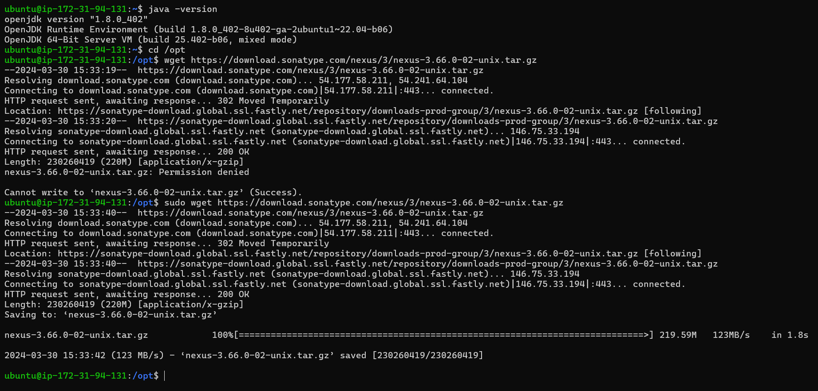

Untar the nexus tar file

-zxvf

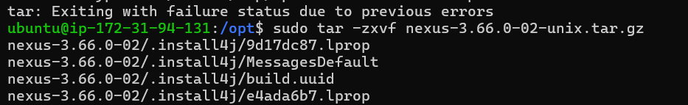

Two folders are created: nexus and sonatype

Nexus stores libraries to run the app

Sonatype contains your metadata uploaded, logs , config files, backup your data ,etc

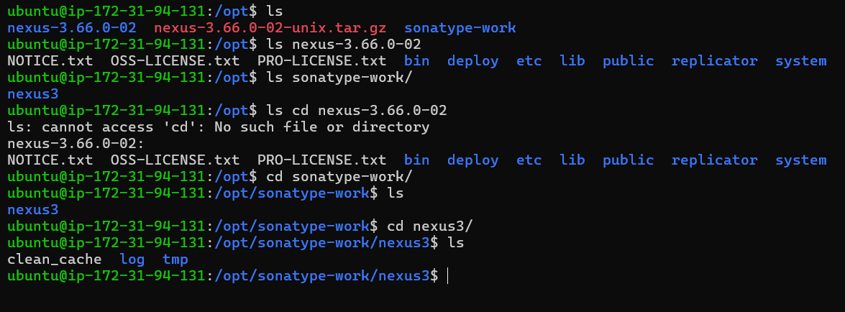

* We shouldn’t start the nexus service from root user, so creating a separate linux user for running nexus

adduser nexus; usermod -aG sudo nexus

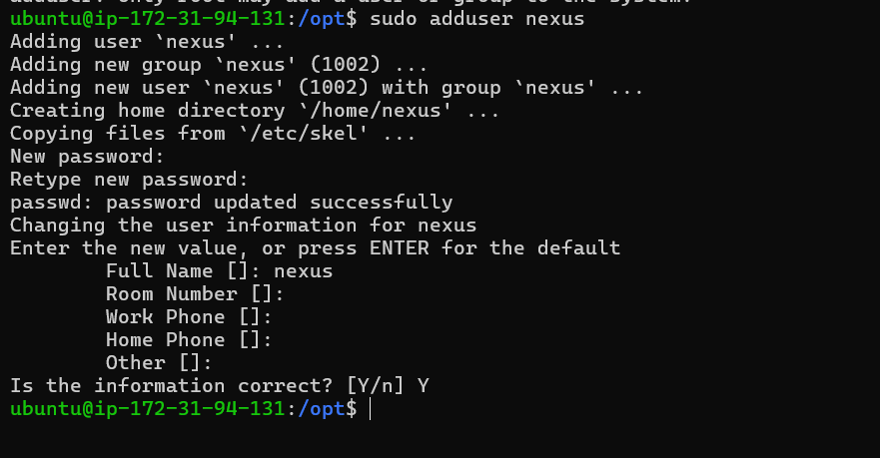

To run the nexus as nexus user, we need to reassign owners for these two folders

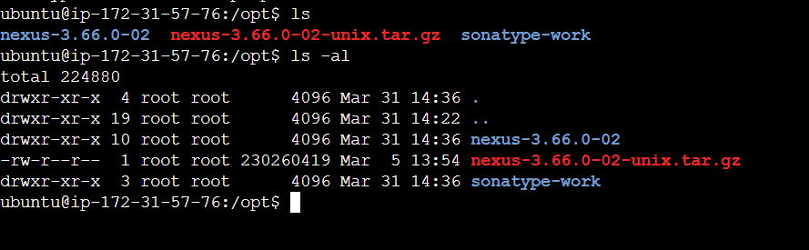

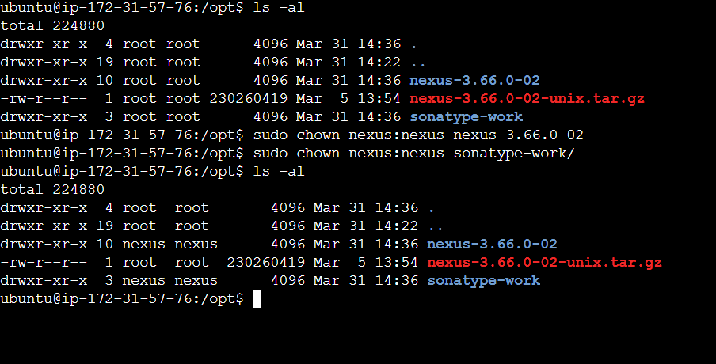

Setting up nexus configuration 🡪 nexus.rc file

Add write permission to nexus.rc file in order to edit it (chmod 777 nexus.rc)

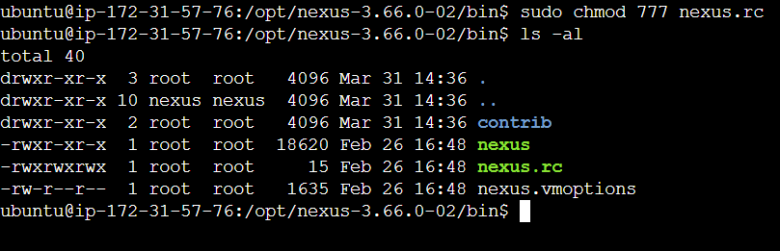

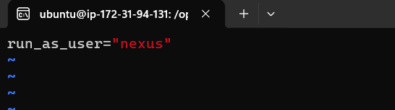

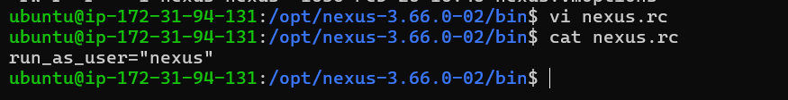

Check whether application is running or not

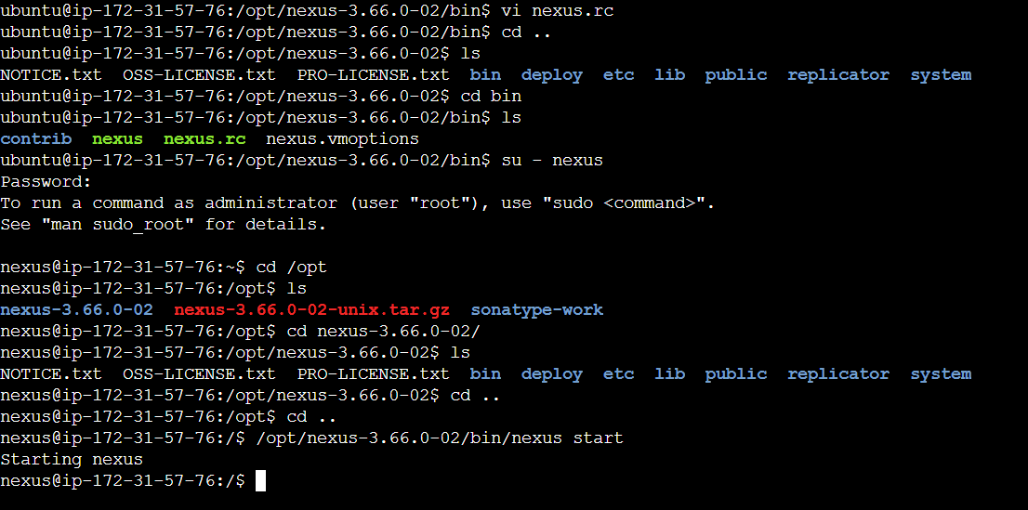

Nexus should be open to accept external requests on port 8081, open port 8081 (inbound rules) from all sources on ec2 instance so that we can access nexus from browser

Adding nexus user to sudo group

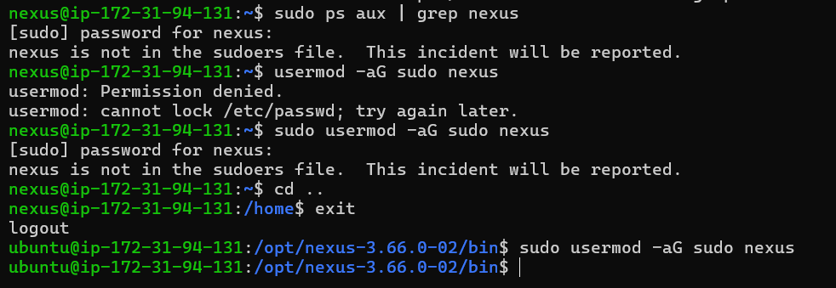

sudo vi /etc/nexus/bin/nexus.vmoptions

Change the default max memory heap for your Nexus installation in the following options. You can change the size to '1024m' based on the memory that you have on your server.

-Xms1024m

-Xmx1024m

-XX:MaxDirectMemorySize=1024m

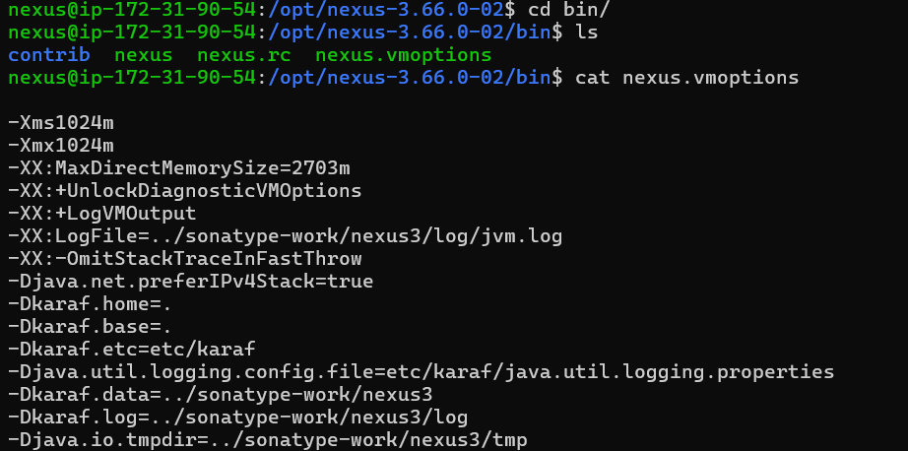

The default value for the HTTP port used to access the repository manager user interface and resources is 8081. Therefore the user interface would be available at http://localhost:8081/. To change or update the port, locate the lineapplication-port=8081 in$data-dir/etc/nexus.properties, then edit the number. Here is an example where you would change the port to9081:

sudo nano /opt/sonatype-work/nexus3/etc/nexus.properties

application-host=127.0.0.1

application-port=9081

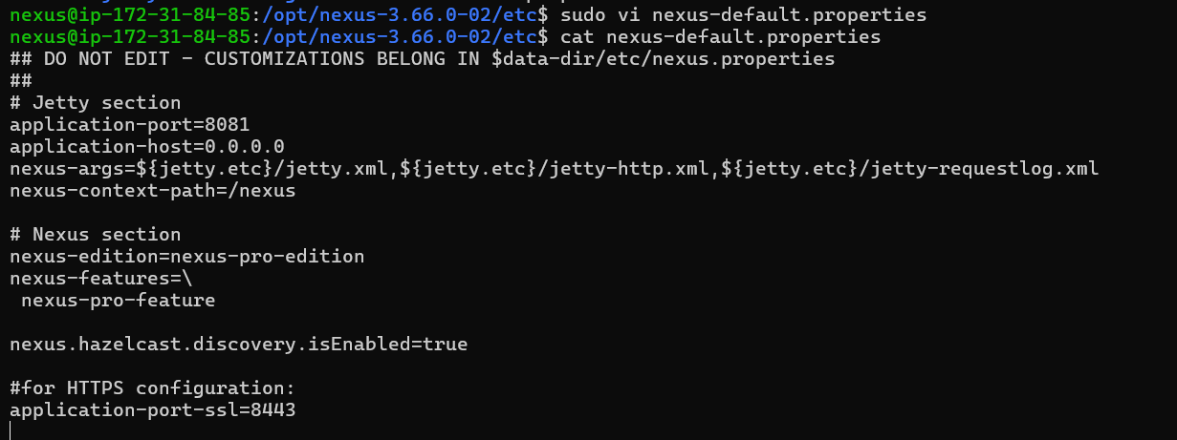

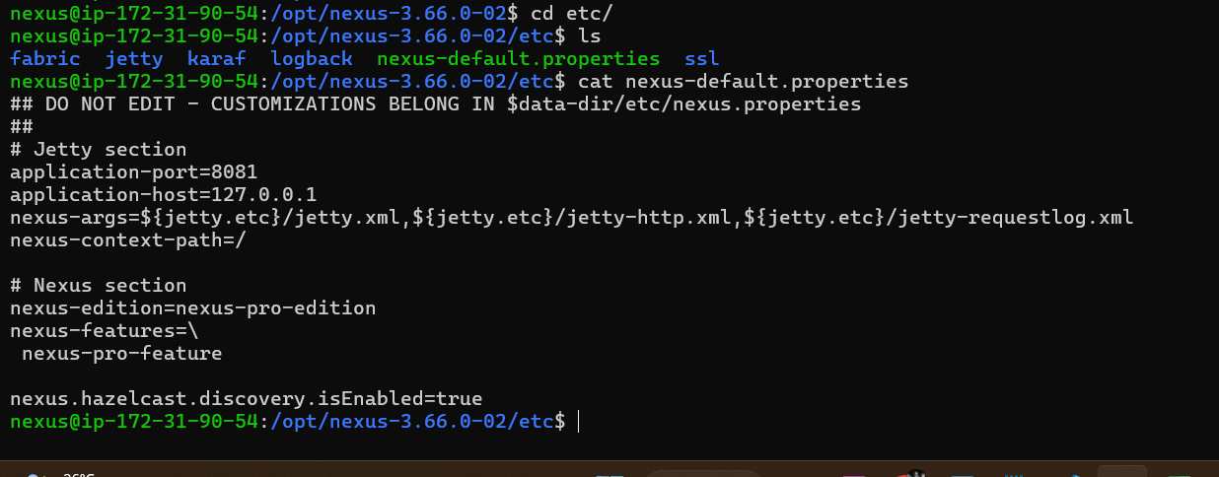

Nexus start

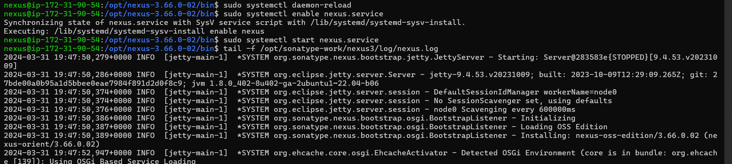

Processes running

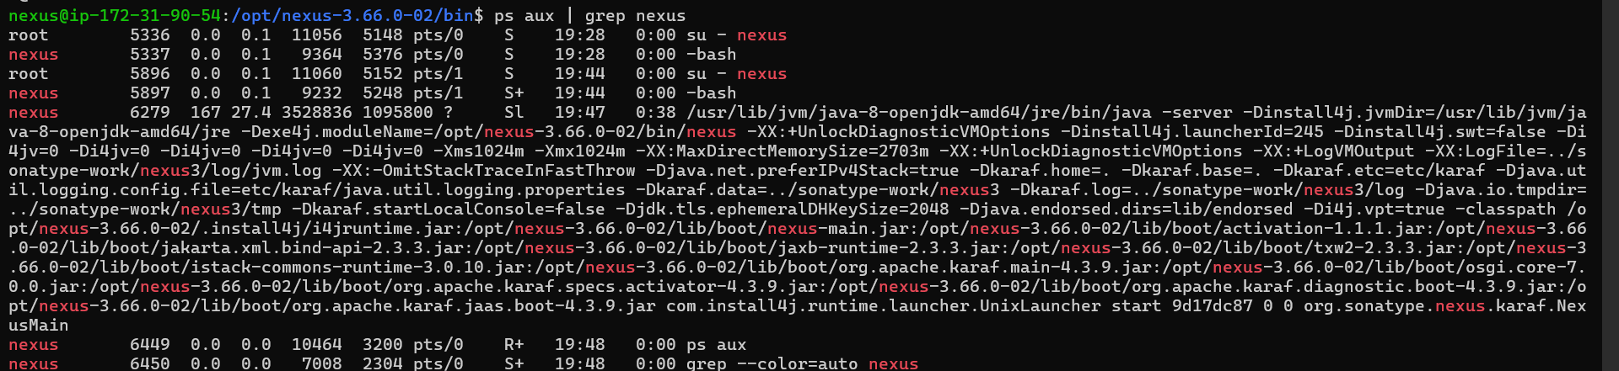

To check on which port nexus is running

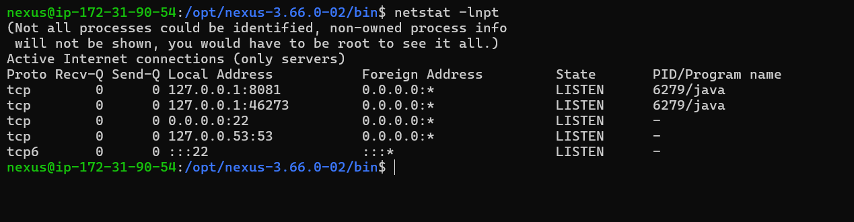

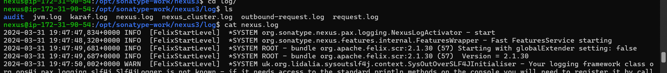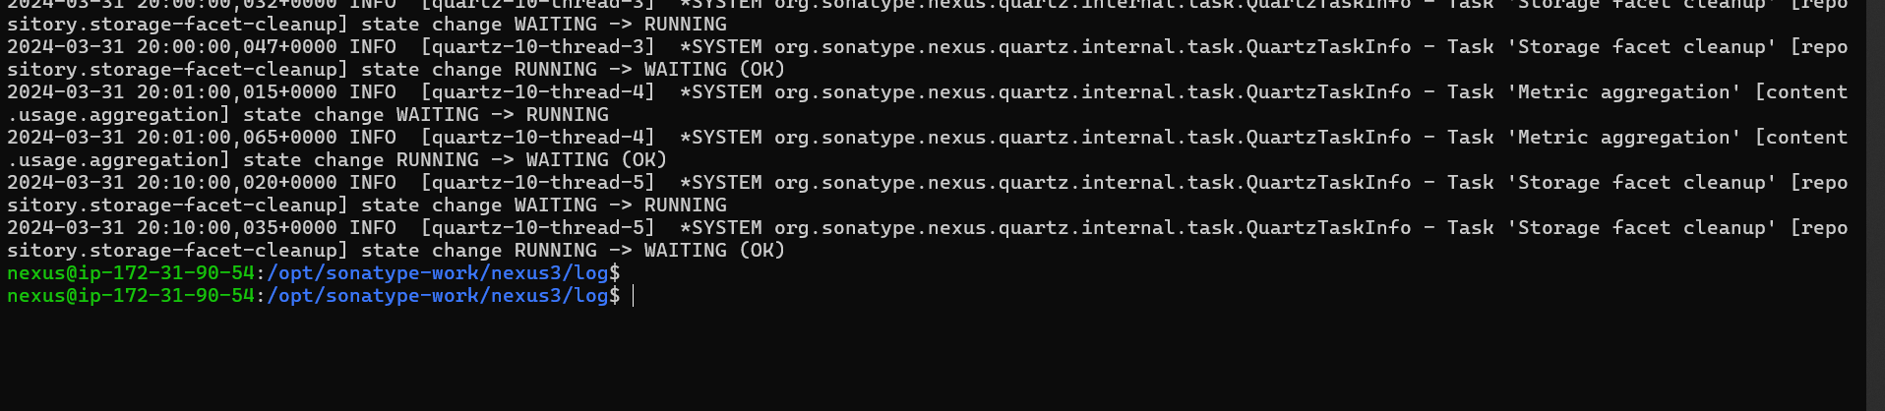

Access UI from public ipv4:8081

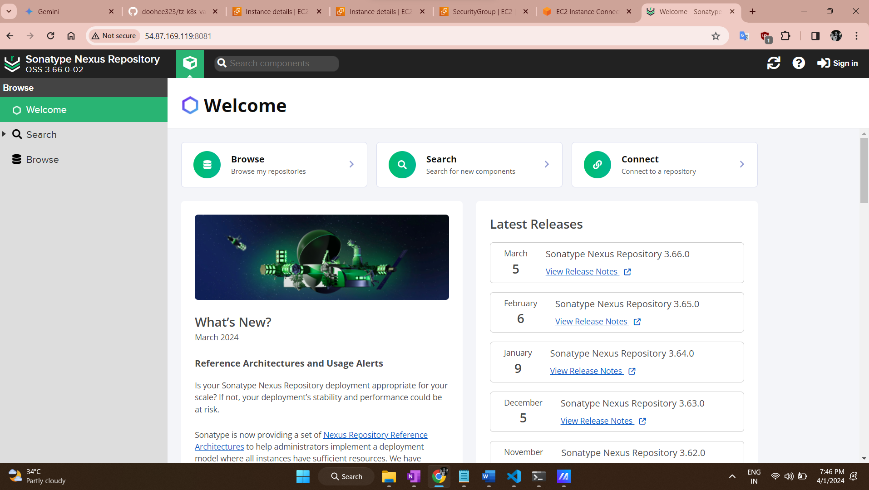

Get password

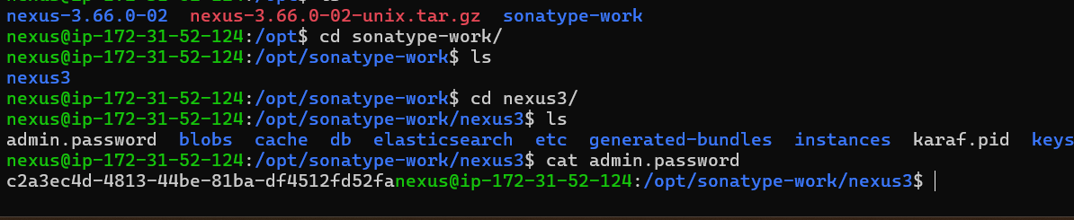

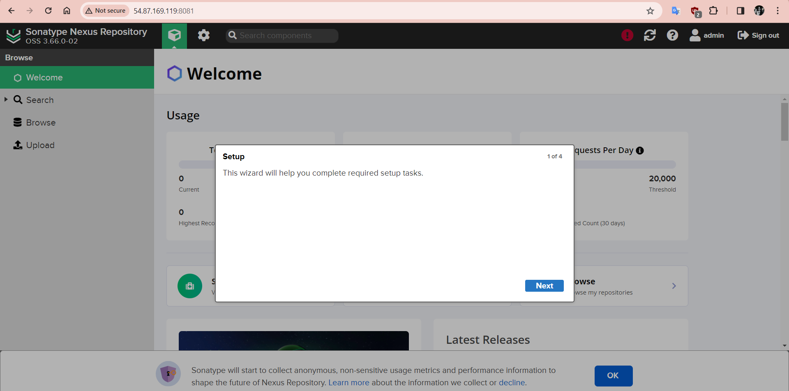

Set admin pwd

Create nexus service user to upload jar files

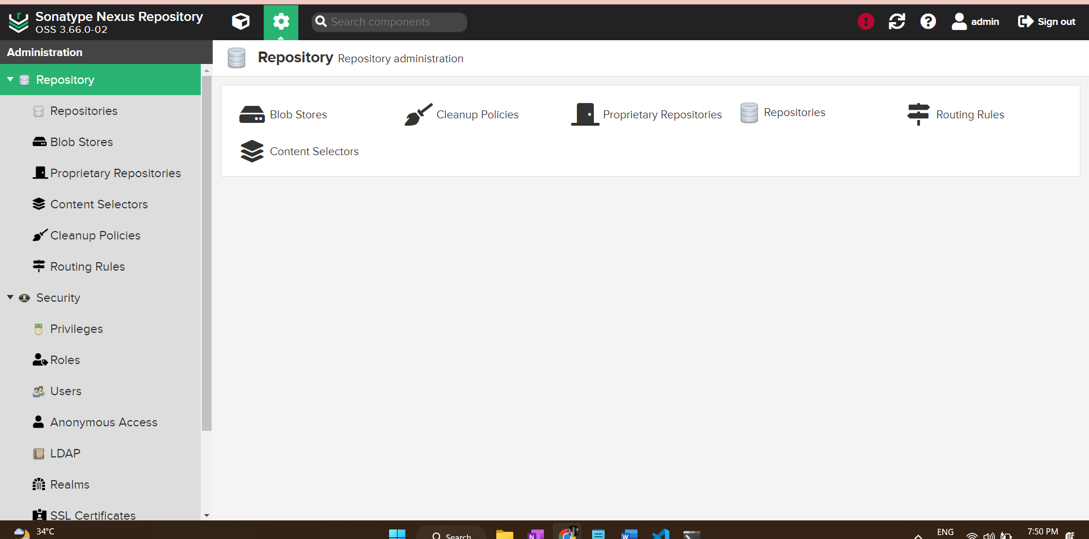

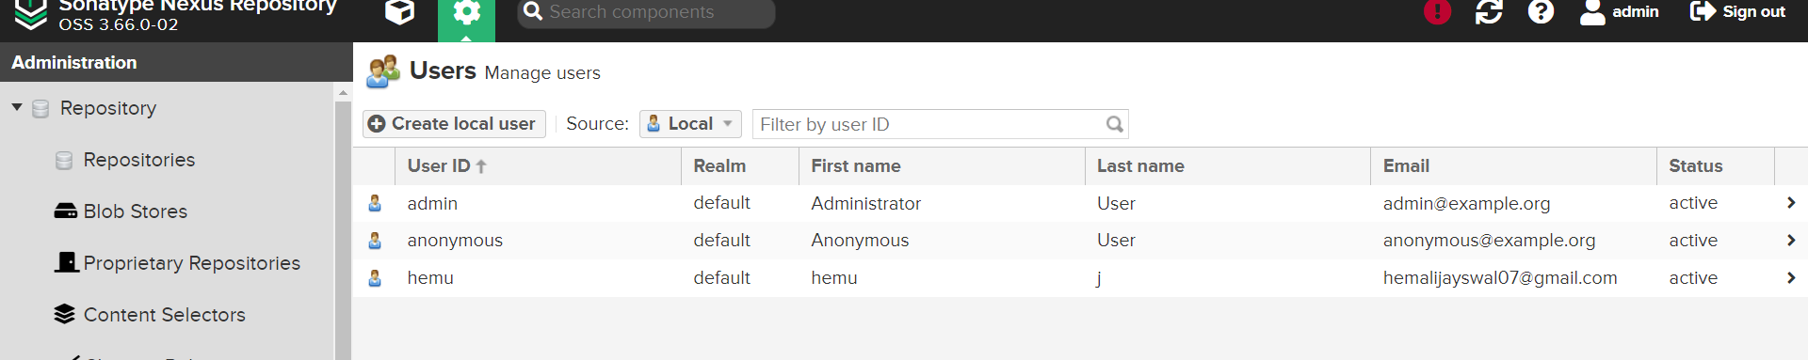

create role for this user ->security -> roles -> create role

Add view-maven snapshot rule to this user

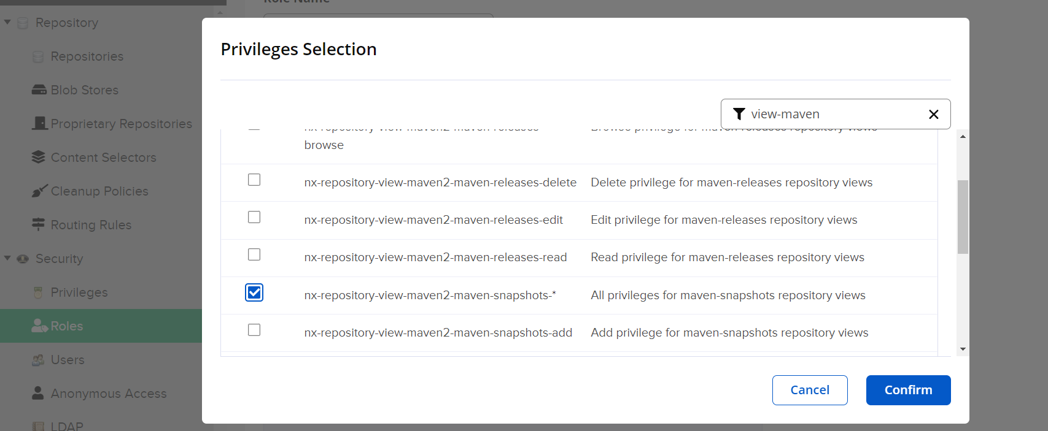

Attach rule to user

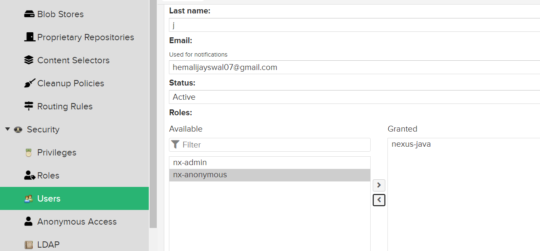

#Nexus is not running because of low space – check in log files in /opt/nexus

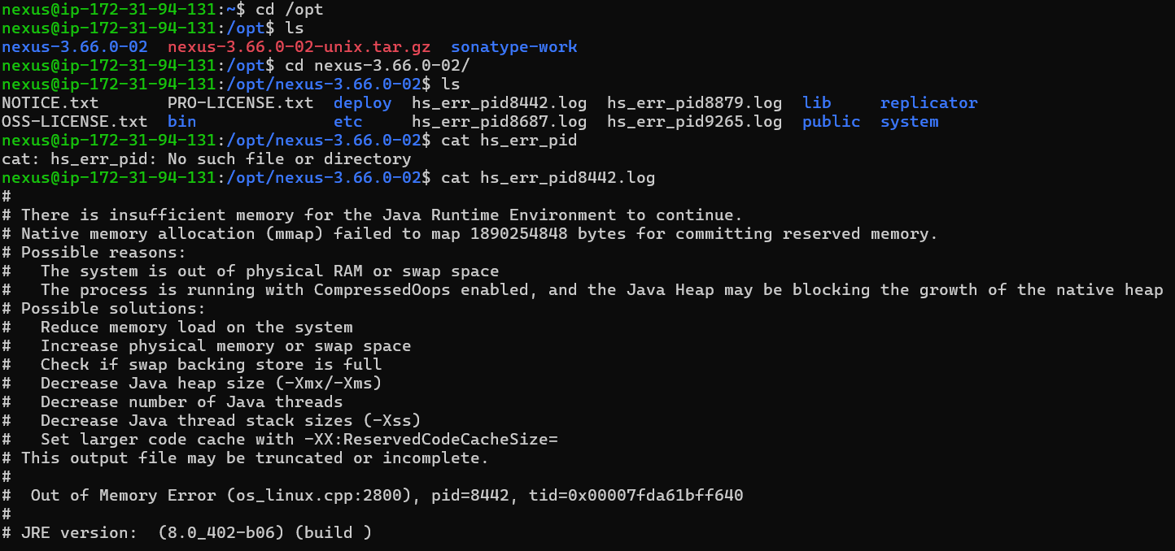

Nexus needs nexus.xml file to start

